**Requirement Gathering and Analysis Phase**

**Solution Architecture**

|  |  |
| --- | --- |
| Date |  |
| Team ID | SWTID1720278137 |
| Project Name | Project – Online Learning Platform |
| Maximum Marks |  |

**Solution Architecture:**

Solution architecture is a complex process – with many sub-processes – that bridges the gap between business problems and technology solutions. Its goals are to:

* Find the best tech solution to solve existing business problems.
* Describe the structure, characteristics, behaviour, and other aspects of the software to project stakeholders.
* Define features, development phases, and solution requirements.
* Provide specifications according to which the solution is defined, managed, and delivered.

**Example - Solution Architecture Diagram:**

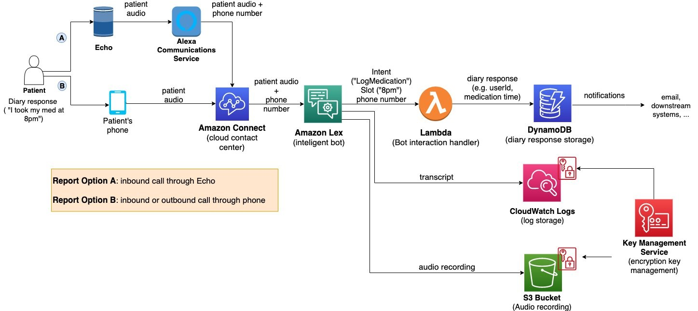

Figure 1: Architecture and data flow of the voice patient diary sample application

**Reference:** [**https://aws.amazon.com/blogs/industries/voice-applications-in-clinical-research-powered-by-ai-on-aws-part-1-architecture-and-design-considerations/**](https://aws.amazon.com/blogs/industries/voice-applications-in-clinical-research-powered-by-ai-on-aws-part-1-architecture-and-design-considerations/)

**EDU-SPHERE (ONLINE LEARNING PLATFORM) – ARCHITECTURE**

+------------------------------+

| User Devices |

|------------------------------|

| - Web Browsers |

| - Mobile Apps |

+------------------------------+

|

v

+------------------------------+

| Frontend Layer |

|------------------------------|

| - React.js / Angular / Vue.js|

| - Responsive Design |

| - Authentication (OAuth) |

| - Content Delivery Network |

+------------------------------+

|

v

+------------------------------+

| Backend Layer |

|------------------------------|

| - Node.js / Django / Flask |

| - RESTful API / GraphQL |

| - Business Logic |

| - Authentication & Security |

+------------------------------+

|

v

+---------------------------------------------------------------+

| Data and Storage Layer |

|---------------------------------------------------------------|

| - Relational Database (PostgreSQL / MySQL) |

| - NoSQL Database (MongoDB / Firebase) |

| - Data Warehouse (Amazon Redshift / Google BigQuery) |

| - Cloud Storage (AWS S3 / Google Cloud Storage) |

| - Blob Storage for Multimedia (AWS S3 / Azure Blob Storage) |

+---------------------------------------------------------------+

|

v

+---------------------------------------------------------------+

| Third-party Integrations |

|---------------------------------------------------------------|

| - Payment Gateway (Stripe / PayPal) |

| - Email Service (SendGrid / Mailchimp) |

| - Analytics (Google Analytics / Mixpanel) |

| - Video Hosting (Vimeo / YouTube) |

| - Real-time Communication (Twilio / Zoom) |

| - VR/AR SDK (Unity / Unreal Engine) |

+---------------------------------------------------------------+

|

v

+---------------------------------------------------------------+

| DevOps and Monitoring |

|---------------------------------------------------------------|

| - CI/CD (Jenkins / GitHub Actions) |

+---------------------------------------------------------------+

|

v

+---------------------------------------------------------------+

| Security and Compliance |

|---------------------------------------------------------------|

| - Web Application Firewall (AWS WAF / Cloudflare) |

| - DDoS Protection (AWS Shield / Cloudflare) |

| - Data Encryption (AES-256, SSL/TLS) |

| - Compliance Management (GDPR, HIPAA) |

+---------------------------------------------------------------+